Dataset 4: Multitasking Frequency & Divided Attention Errors

Scenario Overview
Students recorded how many task-switching events occurred during a study session and then completed a dual-task test. Errors on the dual-task trial were recorded. The scatterplot shows task-switching frequency versus errors.

Data Summary
Task-switching events per session | Errors on dual-task trial
2 | 5
3 | 3
4 | 6
5 | 5
6 | 4
7 | 7
8 | 5
9 | 8
10 | 6
4 | 4
6 | 6
8 | 7

Figure
Figure 1. Task-switching events vs errors. Pearson’s correlation (r) = 0.63.
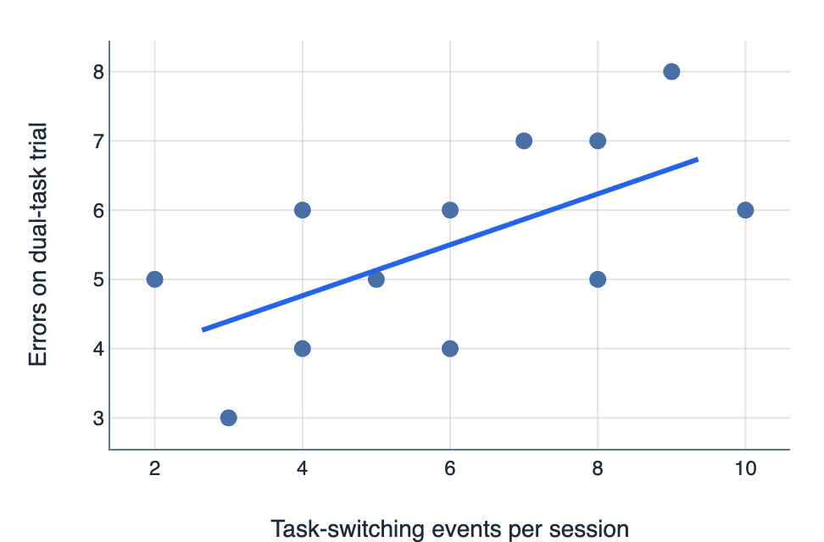

IA1 Practice Questions
- Predict: Using the line of best fit, predict the number of errors for a session with 7 switching events.

- Interpret: Interpret the strength of the relationship between task-switching and errors, referencing the r-value provided.

- Identify: Identify the overall relationship and one anomaly in the scatterplot.

- Compare: Compare the cluster of low switching (2–4) with high switching (8–10) sessions.

- Draw: Draw a conclusion about the cost of frequent task switching.

- Justify: Justify one methodological limitation of this study.

